Data Science Unit 5: Data Visualization

Unit overview
Part | Syllabus topics | What you produce
matplotlib | A brief matplotlib API primer | Line, bar, scatter and histogram charts with titles, labels and legends
pandas plotting | Plotting functions in pandas | Charts straight from a Series or DataFrame in one line
Time series | Dates, indexing, resampling, shifting, rolling windows | Trends over time and smoothed or re-sampled views
Applications | Financial and economic data | Returns, moving averages and correlation of prices and indicators
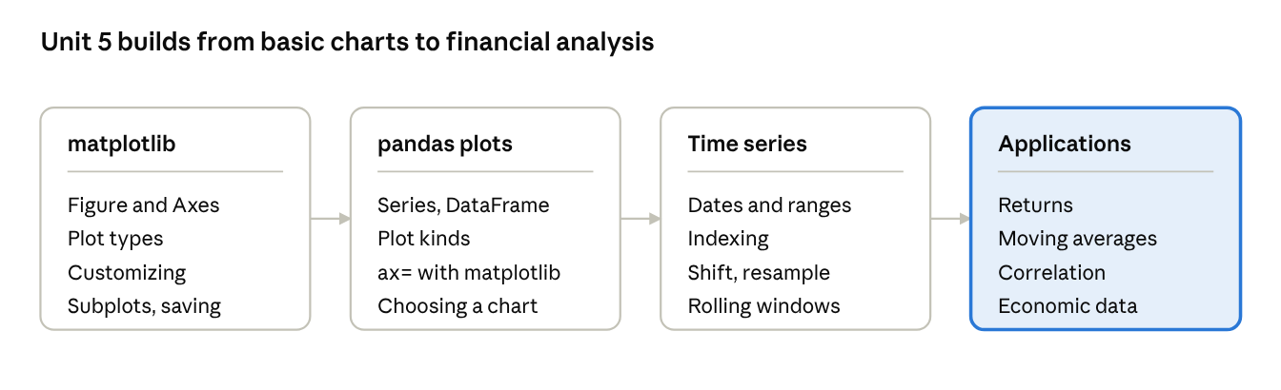
unit roadmap · 4 parts

1. A Brief matplotlib API Primer
matplotlib is the foundation of Python plotting: you create a Figure, draw on one or more Axes inside it, and then style and save the result.

1.1 Figure, Axes and the two interfaces
A Figure is the whole canvas (the window or image). An Axes is one plot area inside it, with its own x-axis, y-axis, title and labels. One Figure can hold many Axes.
matplotlib has two ways to draw. The pyplot (state-based) style calls plt.plot(...) and works on whichever Axes is current, which is quick for experiments. The object-oriented style keeps explicit fig and ax objects, which is clearer and is preferred for anything with more than one plot.
import matplotlib.pyplot as plt
import numpy as np
x = np.linspace(0, 10, 100)
fig, ax = plt.subplots(figsize=(6, 4)) # one Figure holding one Axes
ax.plot(x, np.sin(x), label="sin(x)", color="tab:blue", linestyle="-")
ax.plot(x, np.cos(x), label="cos(x)", color="tab:orange", linestyle="--")
ax.set_title("Sine and cosine")
ax.set_xlabel("x")
ax.set_ylabel("value")
ax.legend() # uses the label= text of each line
ax.grid(True)
fig.savefig("waves.png", dpi=150) # save to a file
plt.show() # display the window
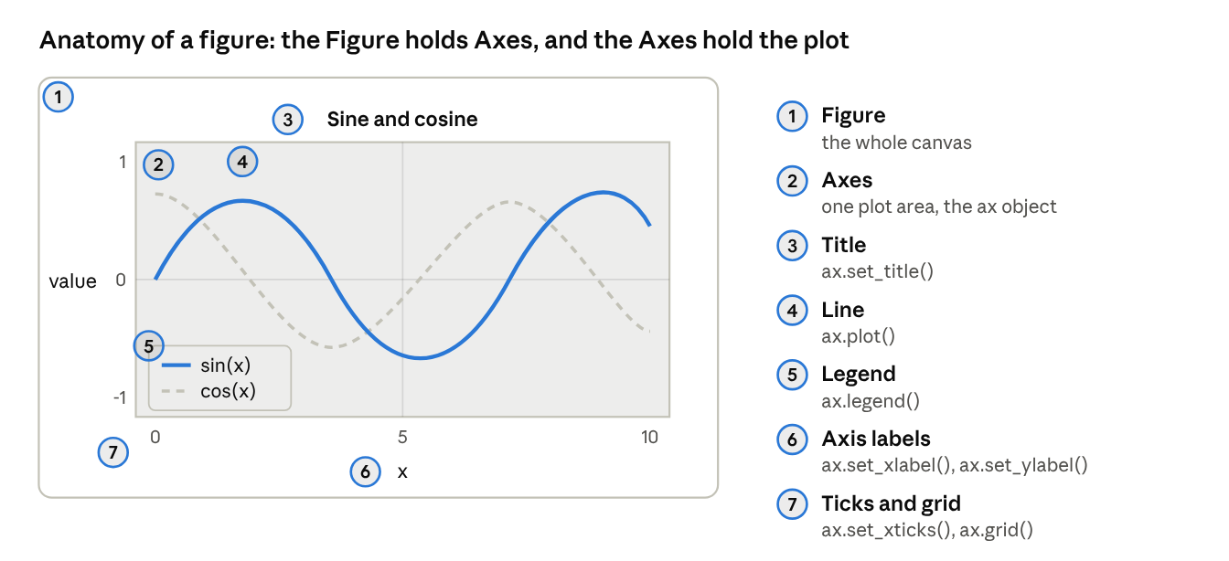
figure anatomy · 7 labelled parts
The numbers on the picture match the numbered list: each part of the chart is created or changed by one method of the ax object.

1.2 Plot types
Method | Chart | Use it to show
ax.plot(x, y) | Line | A trend, usually over time
ax.scatter(x, y) | Scatter | The relationship between two numeric variables
ax.bar(names, heights) / ax.barh | Bars (vertical or horizontal) | Comparing categories
ax.hist(values, bins=10) | Histogram | The distribution of one variable
ax.boxplot(data) | Box plot | Median, quartiles and outliers of groups
ax.pie(sizes, labels=...) | Pie | Parts of a whole, for a few categories only
ax.errorbar(x, y, yerr=e) | Line with error bars | Uncertainty in measurements
ax.fill_between(x, y1, y2) | Shaded band | A range or confidence interval
ax.imshow(matrix) | Image or heat map | A grid of values such as a correlation matrix
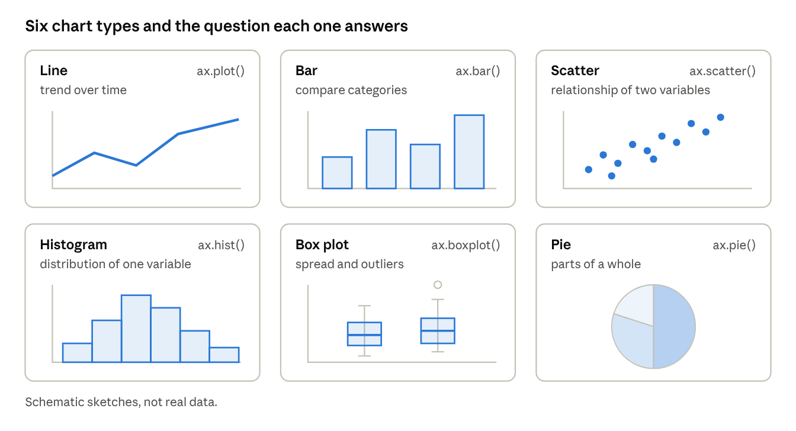
chart type gallery · 6 schematic sketches
fig, (ax1, ax2, ax3) = plt.subplots(1, 3, figsize=(12, 3.5))
ax1.bar(["CSE", "IT", "ECE"], [72, 65, 58], color="tab:blue") # bars
ax1.set_title("Average marks")
rng = np.random.default_rng(1)
ax2.scatter(rng.normal(size=50), rng.normal(size=50), alpha=0.6) # scatter
ax2.set_title("Scatter")
ax3.hist(rng.normal(size=500), bins=20, color="tab:green") # histogram
ax3.set_title("Histogram")
fig.tight_layout()
plt.show()

1.3 Customizing a chart
- Lines and markers: color, linestyle ("-", "--", ":"), linewidth, marker ("o", "s", "^") and markersize. A format string combines them: ax.plot(x, y, "ro--") means red circles joined by a dashed line.
- Text: set_title, set_xlabel, set_ylabel, ax.text(x, y, "note") and ax.annotate("peak", xy=(5, 1), xytext=(6, 1.2), arrowprops=dict(arrowstyle="->")).
- Limits and ticks: set_xlim(0, 10), set_ylim(-1, 1), set_xticks([0, 5, 10]), set_xticklabels(["low", "mid", "high"]).
- Legend: ax.legend(loc="upper right"); every plotted item needs a label=.
- Appearance: ax.grid(True), plt.style.use("ggplot") for a ready-made theme, and fontsize= on any text.
- Colours: names ("tab:red"), single letters ("r") or hex codes ("#2a7ae2"); alpha sets transparency.

1.4 Subplots
plt.subplots(nrows, ncols) returns the Figure and an array of Axes. With one row or column the array is one-dimensional, otherwise it is two-dimensional.
fig, axes = plt.subplots(2, 2, figsize=(8, 6), sharex=True) # 2 x 2 grid sharing the x-axis
axes[0, 0].plot(x, np.sin(x)); axes[0, 0].set_title("sin")
axes[0, 1].plot(x, np.cos(x)); axes[0, 1].set_title("cos")
axes[1, 0].plot(x, x); axes[1, 0].set_title("line")
axes[1, 1].plot(x, x ** 2); axes[1, 1].set_title("square")
fig.tight_layout() # stop titles and labels overlapping

1.5 Saving figures
fig.savefig("chart.png", dpi=300, bbox_inches="tight") writes an image; the extension chooses the format (.png, .pdf, .svg, .jpg). Use PDF or SVG when the chart must stay sharp at any size, and PNG for web pages. In a Jupyter notebook, charts appear under the cell automatically.

2. Plotting Functions in pandas
Series and DataFrame have a built-in plot method that uses matplotlib underneath, so one line of code gives a labelled chart and the index and column names become the axis and legend automatically.

2.1 Series and DataFrame plots
import pandas as pd
import matplotlib.pyplot as plt
df = pd.DataFrame({
"year": [2022, 2023, 2024, 2025],
"CSE": [60, 72, 81, 90],
"IT": [40, 52, 55, 70],
}).set_index("year")
df.plot() # one line per column; the index is the x-axis
df.plot(kind="bar") # grouped bars
df.plot(kind="bar", stacked=True) # stacked bars
df["CSE"].plot(title="CSE admissions", color="tab:blue", marker="o")
plt.show()
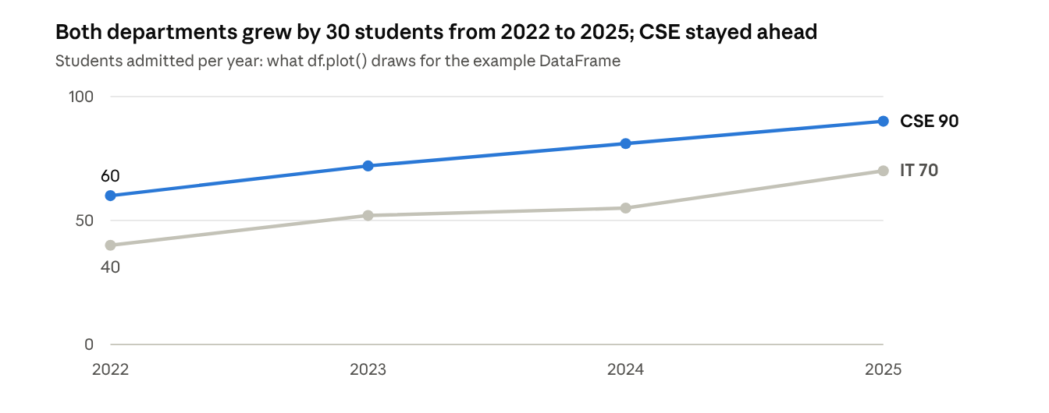
example DataFrame from section 2.1 · 2022 to 2025
The index (years) becomes the x-axis and each column becomes one line with its own legend entry, with no extra code.
The kind argument chooses the chart; each kind also has a method form such as df.plot.bar().
kind | Chart | Typical use
"line" (default) | Line plot | Trends over time
"bar", "barh" | Vertical or horizontal bars | Comparing categories; add stacked=True for parts of a total
"hist" | Histogram | Distribution of one column
"kde" or "density" | Smooth density curve | Shape of a distribution
"box" | Box plot | Spread and outliers per column
"scatter" | Scatter (needs x= and y=) | Relationship between two columns
"area" | Filled area | Cumulative totals over time
"pie" | Pie chart | Shares of a whole

2.2 Useful plot options
- title, xlabel, ylabel, legend=False, grid=True
- figsize=(8, 4) for the size, rot=0 to rotate tick labels, alpha=0.6 for transparency
- subplots=True draws each column in its own panel, with layout=(2, 2) to arrange them
- logy=True for a logarithmic y-axis, xlim and ylim to set the range, colormap for a colour scheme
# NumPy supplies random sample data for this example
import numpy as np
rng = np.random.default_rng(0)
data = pd.DataFrame({
"height": rng.normal(165, 8, 200),
"weight": rng.normal(62, 9, 200),
})
data["height"].plot.hist(bins=15, alpha=0.7, title="Height distribution")
data.plot.scatter(x="height", y="weight", alpha=0.5) # relationship of two columns
data.plot.box() # one box per column
pd.plotting.scatter_matrix(data, figsize=(5, 5)) # all pairs of columns

2.3 Combining pandas with matplotlib
Every pandas plot method returns a matplotlib Axes, and accepts one through ax=. That lets you place several pandas charts on one Figure and finish the styling with matplotlib.
fig, (left, right) = plt.subplots(1, 2, figsize=(10, 4))
df.plot(ax=left, title="Lines")
df.plot.bar(ax=right, title="Bars")
right.set_ylabel("Students")
fig.tight_layout()
fig.savefig("admissions.png", dpi=150)
The seaborn library builds on matplotlib and pandas to give statistical charts such as heat maps and pair plots with attractive defaults; it works directly with DataFrames.

2.4 Choosing the right chart
Your goal | Good choice
Show change over time | Line plot
Compare values across categories | Bar chart (horizontal when the names are long)
Show how values are distributed | Histogram, density plot or box plot
Show the relationship between two numeric columns | Scatter plot, with a scatter matrix for many columns
Show parts of a whole | Stacked bar (a pie only for very few parts)
Show a grid of values such as correlations | Heat map (imshow or seaborn)
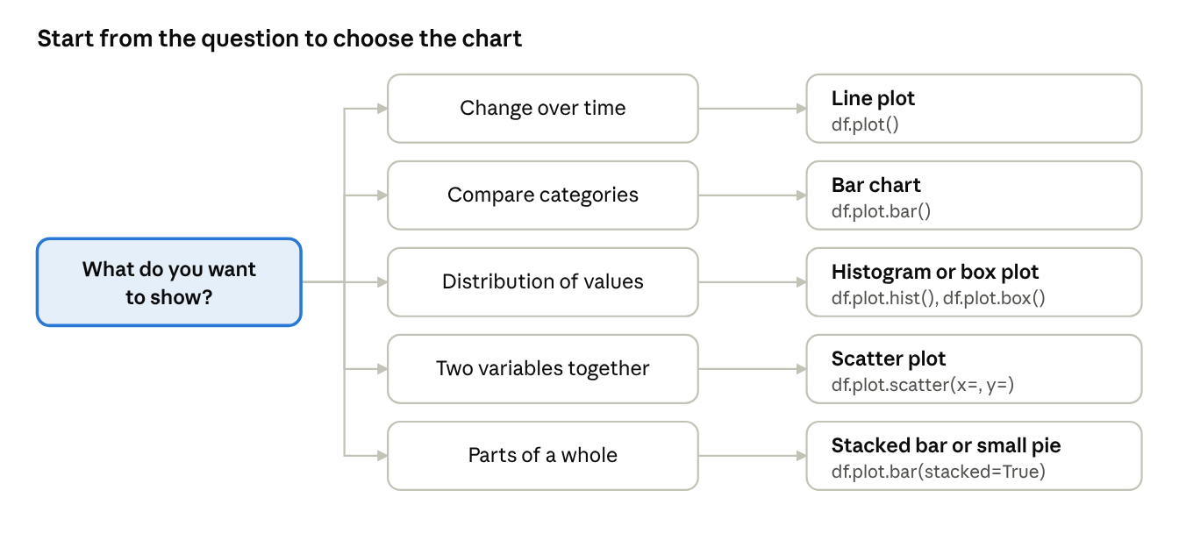
chart chooser · 5 questions

3. Time Series
A time series is data indexed by time; pandas stores it with a DatetimeIndex, which makes selecting periods, changing the frequency and computing moving averages one-line operations.

3.1 Date and time types and date ranges
Python's datetime module has date, time and datetime objects; pandas adds Timestamp (one moment), Timedelta (a duration) and Period (a span such as a month). pd.to_datetime converts text to timestamps, and pd.date_range builds a regular sequence of dates.
import numpy as np
import pandas as pd
print(pd.to_datetime("2026-03-05")) # Timestamp('2026-03-05 00:00:00')
print(pd.to_datetime(["05/03/2026"], dayfirst=True)) # day before month
rng = pd.date_range("2026-01-01", periods=90, freq="D") # 90 daily dates
ts = pd.Series(np.arange(90, dtype=float), index=rng)
print(ts.head(3))
# 2026-01-01 0.0
# 2026-01-02 1.0
# 2026-01-03 2.0
Frequency code | Meaning
"D" | Calendar day
"B" | Business day (Monday to Friday)
"W" | Week (ending on Sunday)
"MS" | Month start
"ME" | Month end (older pandas versions write "M")
"h", "min" | Hour, minute

3.2 Time series indexing and selection
With a DatetimeIndex you can select by date strings, and a partial string such as a month selects the whole period.
print(ts["2026-02-10"]) # one day: 40.0
print(ts["2026-03"].head(2)) # every day of March
print(ts["2026-02-01":"2026-02-05"]) # a slice; both ends are included
print(ts.index.month[:3]) # parts of the date are available: Index([1, 1, 1])

3.3 Shifting and percentage change
shift(n) moves the data forward (positive) or backward (negative) by n positions while the index stays put, which is how you compare a value with the previous one. pct_change() is the relative change from the previous value.
print(ts.shift(1).head(3).tolist()) # [nan, 0.0, 1.0]
print(ts.shift(-1).head(3).tolist()) # [1.0, 2.0, 3.0]
print(ts.shift(7, freq="D").index[0]) # with freq the INDEX moves: 2026-01-08
price = pd.Series([100.0, 102.0, 101.0], index=pd.date_range("2026-01-01", periods=3))
print(price.pct_change().round(4).tolist()) # [nan, 0.02, -0.0098]

3.4 Time zones
Timestamps are naive (no zone) until you attach one. tz_localize attaches a zone and tz_convert changes it.
stamp = pd.Timestamp("2026-03-05 09:30")
local = stamp.tz_localize("Asia/Kolkata") # attach a time zone
print(local.tz_convert("UTC")) # 2026-03-05 04:00:00+00:00

3.5 Resampling and moving windows
Resampling changes the frequency of a series. Downsampling (daily to monthly) needs an aggregation such as mean or sum; upsampling (monthly to daily) creates gaps that you fill with ffill or interpolation.
Moving window functions compute a statistic over a sliding set of the most recent values, which smooths noise: rolling(window).mean() is a moving average, rolling(window).std() a moving volatility, and expanding() uses everything so far.
monthly = ts.resample("MS").mean()
print(monthly.tolist()) # [15.0, 44.5, 74.0] January, February, March
print(ts.resample("W").sum().head(2)) # weekly totals
ma7 = ts.rolling(7).mean() # 7-day moving average
print(ma7.iloc[5], ma7.iloc[6]) # nan 3.0 the first full window ends on day 7
print(ts.expanding().mean().iloc[3]) # 1.5 mean of the first four values
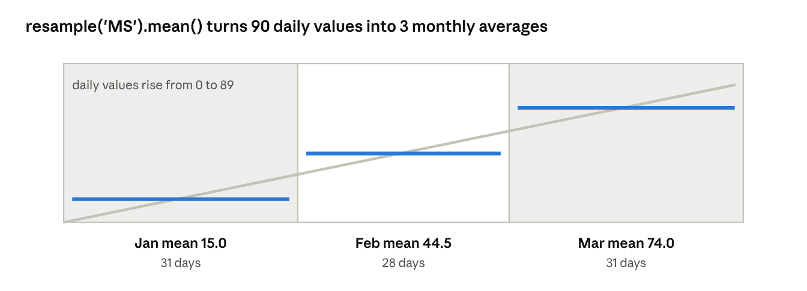
monthly averages from the 90-day example
Each monthly average sits halfway up its band, because the daily values rise steadily.
The first window - 1 results of a rolling calculation are NaN because there are not yet enough values to fill a window; set min_periods to allow shorter windows.
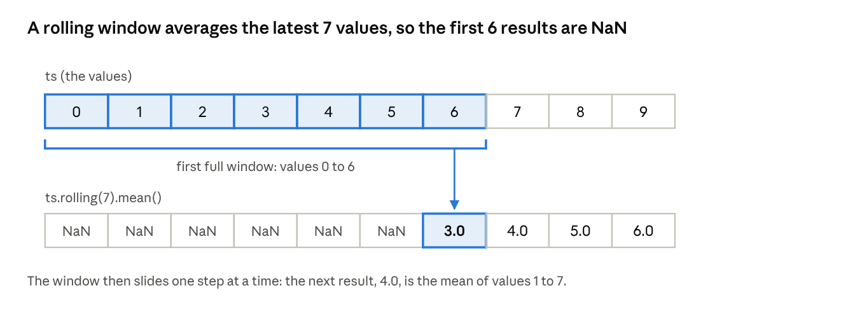
7-day rolling mean · values 0 to 9

4. Financial and Economic Data Applications
Financial and economic data are time series, so the whole unit comes together here: load prices or indicators, convert them to returns, smooth them with moving windows, compare series and chart the result.
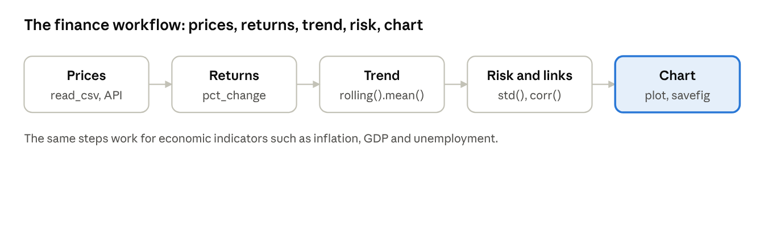
finance workflow · 5 steps

4.1 Getting the data
Market and economic series usually arrive as a CSV file or from a data provider. A CSV with a date column loads straight into a DatetimeIndex.
prices = pd.read_csv("prices.csv", index_col="Date", parse_dates=True)
prices = prices.sort_index()
Libraries such as pandas-datareader and yfinance can download prices and public economic indicators (for example from the World Bank or FRED), but their availability and terms change, so check each library's current documentation. The examples below create their own sample prices so that they run anywhere.

4.2 Returns, moving averages and volatility
Investors look at returns (the percentage change) rather than raw prices because returns are comparable across assets.
r_t = \frac{P_t - P_{t-1}}{P_{t-1}}

import numpy as np
import pandas as pd
import matplotlib.pyplot as plt
rng = np.random.default_rng(42)
dates = pd.bdate_range("2025-01-01", periods=250) # business days only
price = pd.Series(100 + rng.normal(0, 1, 250).cumsum(), index=dates, name="PRICE") # sample prices
ret = price.pct_change() # daily return r_t
log_ret = np.log(price / price.shift(1)) # log return, useful because it adds up over time
cum = (1 + ret).cumprod() - 1 # cumulative return since the start
ma20 = price.rolling(20).mean() # 20-day moving average (trend)
ma50 = price.rolling(50).mean() # 50-day moving average (slower trend)
vol20 = ret.rolling(20).std() # 20-day volatility (risk)
fig, ax = plt.subplots(figsize=(9, 4))
price.plot(ax=ax, label="Price", alpha=0.6)
ma20.plot(ax=ax, label="20-day average")
ma50.plot(ax=ax, label="50-day average")
ax.set_title("Price with moving averages (sample data)")
ax.legend()
plt.show()
Measure | What it tells you | pandas
Daily return | Percentage change from the previous day | price.pct_change()
Cumulative return | Total gain since the start | (1 + ret).cumprod() - 1
Moving average | Smoothed trend; a short average crossing above a long one is a common signal | price.rolling(20).mean()
Volatility | How widely returns vary, a measure of risk | ret.rolling(20).std()
Drawdown | Fall from the highest price so far | price / price.cummax() - 1

4.3 Resampling and comparing several series
monthly_close = price.resample("ME").last() # last price of each month ("M" in older pandas)
monthly_ret = monthly_close.pct_change()
# several assets: correlation of their returns
rets = pd.DataFrame({
"A": price.pct_change(),
"B": price.pct_change() * 0.5 + rng.normal(0, 0.005, 250), # a related sample series
}).dropna()
print(rets.corr()) # correlation matrix: values from -1 to 1
print(rets["A"].rolling(60).corr(rets["B"]).tail(1)) # how the relationship changes over time
indexed = price / price.iloc[0] * 100 # rebase to 100 to compare assets on one chart
Correlation runs from -1 (move in opposite directions) through 0 (unrelated) to +1 (move together); it is the basis of diversification, because assets that do not move together reduce risk.

4.4 Economic indicators
Economic series such as GDP, unemployment and consumer prices are published monthly, quarterly or yearly, so they often have different frequencies. The same tools apply.
- Inflation rate: the 12-month change of a price index, cpi.pct_change(12) * 100 for monthly data.
- Growth rate: gdp.pct_change() for the change from the previous period.
- Aligning frequencies: resample a daily series to monthly, or use ffill to carry a quarterly value across its months, then join the series on the date index.
- Smoothing: a rolling mean removes month-to-month noise to show the trend.
- Indexing to a base year: divide by the base value and multiply by 100 so different indicators start at 100.
# monthly consumer price index (sample numbers) -> year-on-year inflation
cpi = pd.Series(np.linspace(100, 108, 24), index=pd.date_range("2024-01-01", periods=24, freq="MS"))
inflation = cpi.pct_change(12) * 100 # percent change versus the same month a year earlier
print(inflation.dropna().round(2).head(2))
Prices and indicators in this guide are made-up sample data used only to demonstrate the code; they do not describe any real market.

Quick revision
Remember one core idea for each topic.
- Figure and Axes: a Figure is the canvas; an Axes is one plot area with its own axes, title and labels.
- Two interfaces: pyplot (plt.plot) works on the current Axes; the object-oriented style uses fig, ax = plt.subplots().
- Basic plots: plot for lines, scatter, bar, hist, boxplot, pie; each item needs a label= for the legend.
- Customizing: color, linestyle, marker, titles and labels, xlim, ylim, ticks, legend, annotate, grid, styles.
- Subplots and saving: plt.subplots(rows, cols), tight_layout(), savefig(dpi=...) with PNG, PDF or SVG.
- pandas plots: df.plot(kind=...) with the index on the x-axis; it returns an Axes and accepts ax=.
- Chart choice: line for trends, bar for categories, histogram or box plot for distributions, scatter for relationships.
- Time series basics: a DatetimeIndex, date_range with a frequency code, partial string indexing such as ts["2026-03"].
- Shifting: shift(n) moves the data but not the index; pct_change() gives the relative change.
- Resampling: resample("MS").mean() changes frequency; rolling(n).mean() is a moving average.
- Finance: returns are pct_change, cumulative return is (1 + r).cumprod() - 1, volatility is a rolling standard deviation, corr() compares assets.
- Economic data: inflation as a 12-month pct_change; align different frequencies with resample and ffill.

Likely exam questions
Short answer (2 to 3 marks)
- What are a Figure and an Axes in matplotlib?
- Differentiate between the pyplot and the object-oriented interfaces.
- How do you create a 2 by 2 grid of subplots?
- Name four kinds of plot available through df.plot(kind=...).
- What does shift() do on a time series?
- What is the difference between resampling and rolling?
- What is a moving average and why is it used?
Long answer (5 to 10 marks)
- Explain the main matplotlib plot types and how a chart is customised, with a program.
- Explain the plotting functions available in pandas, with examples.
- Explain how time series data is created, indexed and selected in pandas.
- Explain resampling, shifting and moving window functions, with examples.
- Explain how stock price data is analysed in pandas using returns, moving averages and correlation.
- Describe how economic indicators with different frequencies can be aligned and analysed.

References

Text books
- Mark Lutz, Learning Python, O'Reilly.
- Mark Lutz, Programming Python, O'Reilly.
- Wes McKinney, Python for Data Analysis, O'Reilly (matplotlib, plotting with pandas, time series, and financial and economic data applications).

Reference books
- Martin C. Brown, Python: The Complete Reference, McGraw Hill Education.
- Paul Barry, Head First Python, O'Reilly.

